Operating System (CS301)

Assignment - 8

**U19CS012**

1. The Synchronization problem called **Sleeping Barber** is described as follows:

* A barber shop has a **single** barber, a single barber’s chair in a small room, and a large waiting room with **n** seats.
* After servicing one customer, the barber checks whether any customers are waiting in the waiting room. If so, he admits one of them and starts serving him; otherwise, he goes to sleep in the barber’s chair.
* A customer enters the waiting room only if there is at least one vacant seat and either waits for the barber to call him if the barber is busy, or wakes the barber if he is asleep.

Identify the synchronization requirements between the barber and customer processes.

When the Barber wants to address the Person in Waiting Queue and Another Customer enters the shop, then the waiting_customer Queue should be updated appropriately.

**Common Header File {Barber Class}**

*// This is General Header File that Contains the Barber Class*

*#include* <unistd.h>

*#include* <iostream>

*#include* <queue>

*#include* <thread>

*#include* <mutex>

using namespace std;

*// Waiting Room of 'n' Seats*

struct WaitingRoom

{

    int TotalSeats;

    queue<int> Customers;

};

*// Defination of Barber Class*

class Barber

{

private:

*// ID of Barber*

    int id;

public:

*// Default Constructor*

    Barber() {}

*// Constructor with ID*

    Barber(int id)

    {

*this*->id = id;

    }

*// Member Function for Hair Cutting Task {itrs -> Iterations}*

    void doTask(WaitingRoom &room, mutex &mtx, mutex &stdOutMtx, int &itrs)

    {

*while* (true)

        {

            mtx.lock();

*// If Number of Iterations are Zero and No Customer in Waiting Room*

*if* (itrs == -1 && room.Customers.empty())

            {

                mtx.unlock();

*break*;

            }

*// If there is Customer in Waiting Room*

*if* (!room.Customers.empty())

            {

*// The Customer who Came First, Should be Served First*

                int toBeServed = room.Customers.front();

                room.Customers.pop();

                mtx.unlock();

                sleep(1);

*// Mutex to Print the Output {Standarr Output}*

                stdOutMtx.lock();

                cout << "Barber: " << *this*->id << " has done the task for the customer : " << toBeServed << endl;

                stdOutMtx.unlock();

            }

*else*

            {

                mtx.unlock();

                sleep(1);

            }

        }

    }

};

a.) **Code** the barber and customer processes such that deadlocks do not arise.

*// Include the Class Defined in "barberheader" Header File*

*#include* "barberheader.hpp"

*#include* <thread>

*// Maximum Number of Iterations*

*#define* ITR 15

*// Maximum Number of Random Customers*

*#define* MAX_RAND_CUSTOMERS 7

int main()

{

    int size;

    cout << "Enter the size for the Waiting Room : ";

    cin >> size;

    cout << "~~~~~~~~~~~~~~~~~Initializing~~~~~~~~~~~~~~~~~" << endl;

*// Mutex for Handling Mutual Exclusion Problem in Sleeping Barber*

    mutex mtx;

*// Mutex of Std Output {Print on Screen}*

    mutex stdOutMtx;

    Barber barber(0);

    WaitingRoom room({size, queue<int>()});

    int itr = ITR;

*// Create a Thread*

    thread barberThread(&Barber::doTask, ref(barber), ref(room), ref(mtx), ref(stdOutMtx), ref(itr));

*// Intially, there are no Customer in Shop*

    int customer = 0;

    int temp = 0, newCustomers;

*// Randomly Customers will be Coming for itr iterations*

*while* (itr--)

    {

        newCustomers = rand() % MAX_RAND_CUSTOMERS;

        newCustomers = max(0, newCustomers);

*if* (newCustomers > 0)

        {

            temp = 0;

            mtx.lock();

*// Add the Customer to Waiting Queue {If Possible}*

*while* (newCustomers-- && room.Customers.size() < room.TotalSeats)

            {

                room.Customers.push(customer++);

                temp++;

            }

            mtx.unlock();

        }

*// Print the Output on Screen*

        stdOutMtx.lock();

        cout << "~~~~~~~~~~~~~~~~~~~~~~~~~~~~~~~~~~~~~~~~~~~~~~\n";

        cout << "Iteration Number is : " << itr << endl;

        cout << "Customers Added are : " << temp << endl;

        cout << "~~~~~~~~~~~~~~~~~~~~~~~~~~~~~~~~~~~~~~~~~~~~~~\n";

        stdOutMtx.unlock();

        sleep(1);

    }

    barberThread.join();

    cout << "~~~~~~~~~~~~~~~~~Task Completed~~~~~~~~~~~~~~~~~" << endl;

*return* 0;

}

**Output [Colcalc {Linux Environment}]**

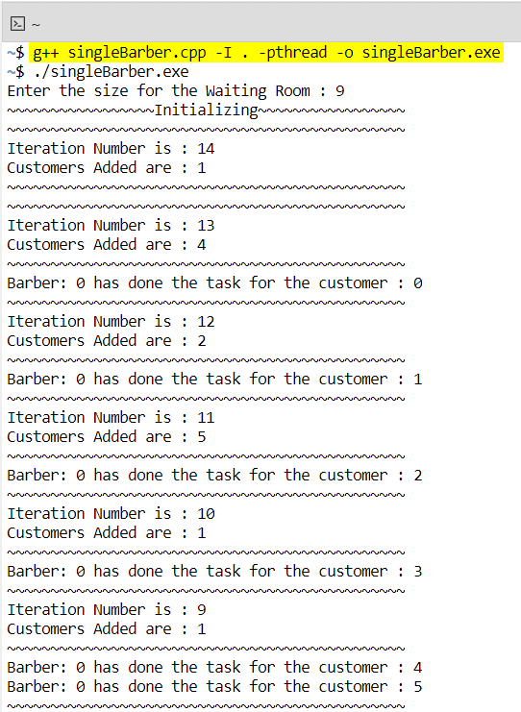

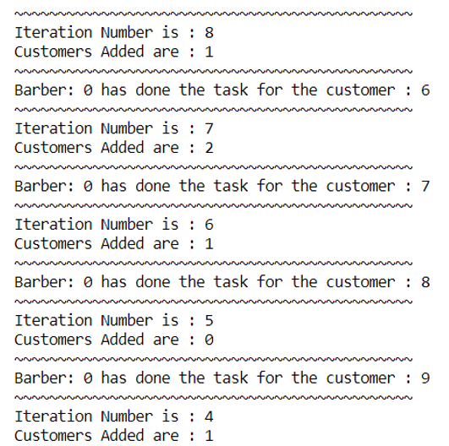

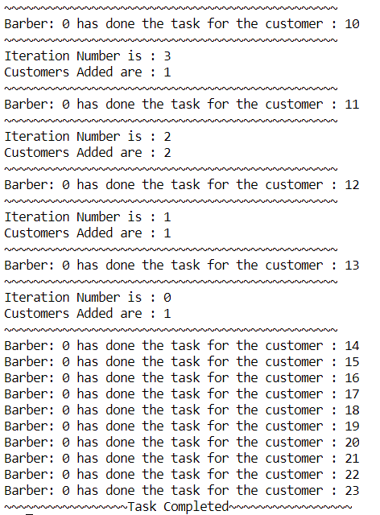

b.) Consider the Sleeping-Barber Problem with the modification that there are k

barbers and k barber chairs in the barber room, instead of just one. Write a

program to coordinate the barbers and the customers.

**Code**

*// Include the Class Defined in "barberheader" Header File*

*#include* "barberheader.hpp"

*#include* <thread>

*// Maximum Number of Iterations*

*#define* ITR 15

*// Maximum Number of Random Customers*

*#define* MAX_RAND_CUSTOMERS 7

*// Same Code from Single Barber is Modified for Multiple Barbers*

int main()

{

    int size, barberCount;

    cout << "Enter the size for Waiting Room : ";

    cin >> size;

    cout << "Enter the number of Barbers     : ";

    cin >> barberCount;

    cout << "~~~~~~~~~~~~~~~~~Initializing~~~~~~~~~~~~~~~~~" << endl;

*// Mutex for Handling Mutual Exclusion Problem in Sleeping Barber*

    mutex mtx;

*// Mutex of Std Output {Print on Screen}*

    mutex stdOutMtx;

    WaitingRoom room({size, queue<int>()});

    int itr = ITR;

    Barber barbers[barberCount];

*// Create 1 Thread for Each Barber*

    thread barberThreads[barberCount];

*for* (int i = 0; i < barberCount; i++)

    {

        barbers[i] = Barber(i);

        barberThreads[i] = thread(&Barber::doTask, ref(barbers[i]), ref(room), ref(mtx), ref(stdOutMtx), ref(itr));

    }

    int customer = 0;

    int temp = 0;

    int newCustomers;

*// Randomly Customers will be Coming for itr iterations*

*while* (itr--)

    {

        newCustomers = rand() % MAX_RAND_CUSTOMERS;

        newCustomers = max(0, newCustomers);

*if* (newCustomers > 0)

        {

            temp = 0;

            mtx.lock();

*while* (newCustomers-- && room.Customers.size() < room.TotalSeats)

            {

                room.Customers.push(customer++);

                temp++;

            }

            mtx.unlock();

        }

*// Print the Output on Screen*

        stdOutMtx.lock();

        cout << "~~~~~~~~~~~~~~~~~~~~~~~~~~~~~~~~~~~~~~~~~~~~~~\n";

        cout << "Iteration Number is : " << itr << endl;

        cout << "Customers Added are : " << temp << endl;

        cout << "~~~~~~~~~~~~~~~~~~~~~~~~~~~~~~~~~~~~~~~~~~~~~~\n";

        stdOutMtx.unlock();

        sleep(1);

    }

*for* (int i = 0; i < barberCount; i++)

        barberThreads[i].join();

    cout << "~~~~~~~~~~~~~~~~~Task Completed~~~~~~~~~~~~~~~~~" << endl;

*return* 0;

}

**Output**

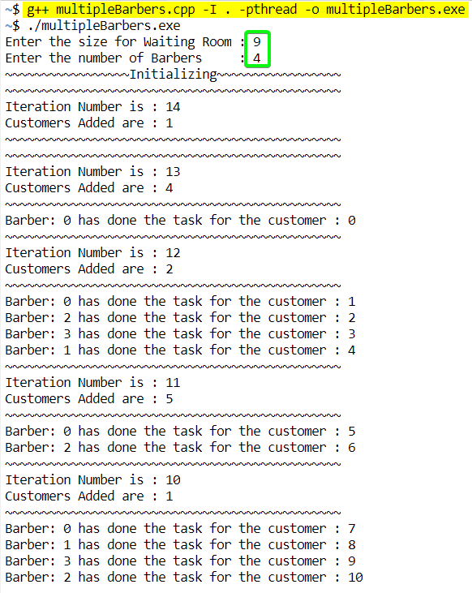

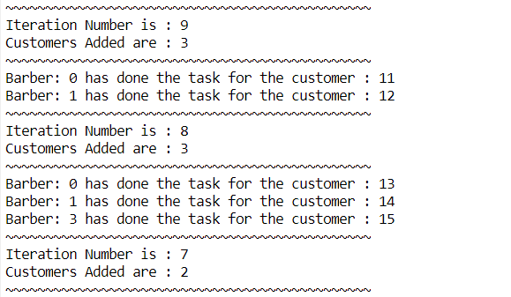

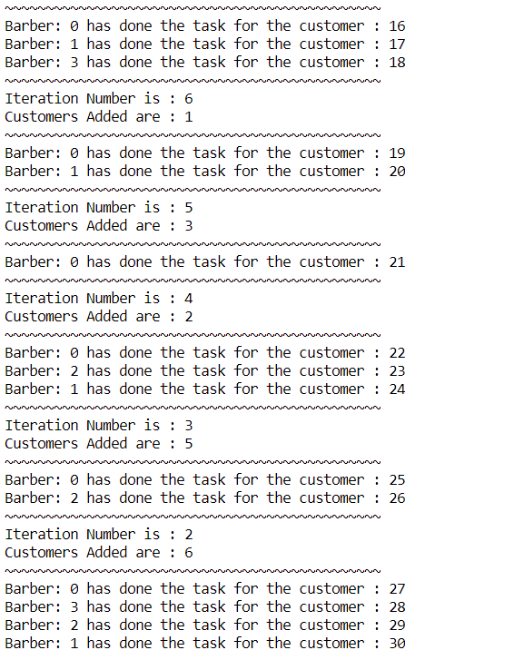

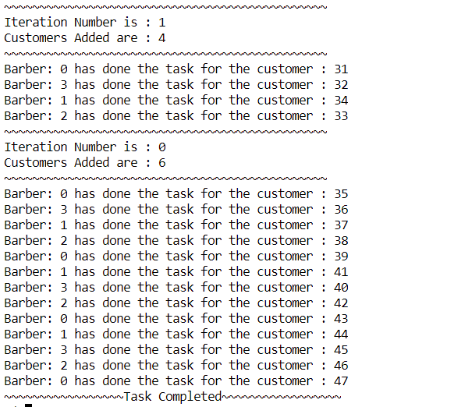

SUBMITTED BY: **U19CS012** BHAGYA VINOD RANA